A

PROJECT REPORT

ON

**Number Plate Detection System**

Towards partial fulfillment of the requirement in

**5th Semester BCA (2021-2022)**

**Submitted By: -**

Jeet Sampat (190510101047)

Bhardwaj Nipun (190510101011)

Tariro Chibwe (190510101025)

**Submitted To: -**



**Parul Institute of Computer Application,**

**Parul University.**

Under the Guidance of

**Prof. Hina Chokshi**

**HOD**

**Acknowledgment**

*The success and final outcome of this project required a lot of guidance and assistance from many people and we are extremely privileged to have got this all along the completion of our project. All that we have done is only due to such supervision and assistance and we would not forget to thank them.*

*I respect and thank Dr. Priya Swaminarayan, Dean, FITCS for providing us an opportunity to do the project work in BCA and giving us all support and guidance, which made us complete the project duly. We are extremely thankful to Mam for providing her support and guidance, although she had busy schedule managing the academic affairs.*

*We would not forget to remember Prof.* *Hina Chokshi, HOD, BCA department for her encouragement and more over for her timely support and guidance till the completion of our project work.*

*We owe our deep gratitude to our project guide Prof. Priya Patel, who took keen interest on our project work and guided us all along, till the completion of our project work by providing all the necessary information for developing a good system.*

*I am thankful to and fortunate enough to get constant encouragement, support and guidance from our Parents, all Teaching staffs of BCA Department which helped us in successfully completing our project work. Also, we would like to extend our sincere esteems to all staff in laboratory for their timely support.*

***[Enrolment No.: - 190510101011]***

***[Enrolment No.: - 190510101047]***

***[Enrolment No.: - 190510101025]***



**PARUL INSTITUTE OF COMPUTER APPLICATION**

**CERTIFICATE**

This is to certify that ***Nipun Bhardwaj, Jeet Sampat, Tariro Chibwe*** the student of Parul Institute of Computer Application, has/have satisfactorily completed the project entitled **“Number Plate Detection System*”*** as a part of course curriculum in BCA / IMCA semester-V for the academic year 2021-2022 under guidance of ***Prof. Hina Chokshi.***

Enrollment Number: 190510101011

Enrollment Number: 190510101047

Enrollment Number: 190510101025

|  |  |  |
| --- | --- | --- |
| **Quality of work** | **Grade** | **Sign of Internal guide** |
| **Poor / Average / Good /**  **Excellent** | **B /B+ / A / A+/O** |  |

Date of submission:

HOD, Principal,

**Prof. Hina Chokshi Dr. Priya Swaminarayan**

**Index**

|  |  |
| --- | --- |
| **Content** | **Page No.** |
| 1. Research | 6 |
| 1. Feasibility Studies | 7-8 |
| * 1. Technical Feasibility | 7 |
| * 1. Economic Feasibility | 8 |
| * 1. Operational Feasibility | 8 |
| 1. System Requirement Specification | 9-11 |
| * 1. Introduction to SRS | 9 |
| * 1. Abstract | 9 |
| * 1. System Users | 10 |
| * 1. Modules | 11 |
| * 1. Modules Description | 11 |
| * 1. Hardware Requirement | 11 |
| * 1. TimeLine Chart | 11 |
| 1. Technology Description | - |
| * 1. Features and Limitations of New System | 12 |
| 1. Data Flow Diagram | 13-16 |
| * 1. Context Level DFD’s | 13 |
| * 1. Level 1 DFD’s | 14 |
| * 1. Level 2 DFD’s | 15 |
| * 1. Level 3 DFD’s | 16 |
| 1. Use Case Diagram | 16 |
| 1. Class Diagram | 17 |
| 1. Activity Diagram | - |
| * 1. Description of Activity Diagram | 18 |
| 1. E-R Diagram | - |
| * 1. E-R Diagram Description | 21 |
| 1. Data Dictionary | - |
| * 1. Description of Data Dictionary | 22 |
| 1. Form Design (Screenshots Phase 1, 2, 3, 4 and Validation’s Screenshots) | 27 |
| 1. What is Testing? | 32 |
| * 1. Importance and Types of Testing | 32 |
| 1. Future Enhancement | 33 |
| 1. References and Bibliography | 33 |

**Chapter 1**

**1. Research**

**What is Research?**

* A careful consideration of study regarding a particular concern or problem using scientific methods. According to the American Sociologist Earl Robert Babbie “Research is a systematic inquiry to describe, explain, predict, and control the observed phenomenon. Research involves inductive and deductive methods.”

**Types of Research:**

* **Applied Research:**The existing system takes up a lot of time and due to that queue for entering also increases. The new system will have a fast and automated system which will help the user also to use.
* **Problem Oriented Research:**The problem in the existing system is that the use of excel is used to store data of the cars coming inside the mall one by one by the guard so the problem is the it takes up a lot of time and labour, so there is no time for the guard to manage the problems in the parking space.
* **Qualitative Research:** We had asked the people coming out of the mall about the system and what we should improve they said that more human interaction is there and they are rude and just provide the ticket without the information about where to go and they take up a lot of time also.

**Chapter 2**

**2. Feasibility Studies**

**2.1 What is** **Feasibility Stud****y?**

A feasibility study, as the name suggests, is designed to reveal whether a project/plan is feasible. It is an assessment of the practicality of a proposed project/plan.

A feasibility study is part of the initial design stage of any project/plan. It is conducted to objectively uncover the strengths and weaknesses of a proposed project or an existing business. It can help to identify and assess the opportunities and threats present in the natural environment, the resources required for the project, and the prospects for success.

**2.1.2 Why is a feasibility study so important for a project?**

For one, the feasibility study is the foundation upon which the rest of your project resides. If it can’t support your project, you don’t have a project. Now that we got your attention, read on to

learn what you need to know about feasibility studies**.**

**2.1 Financial Feasibility:**

As we are making an application in python, the making cost will be free and even the use of the software will be free as the software are opensource type software. Only the cost of hardware requirements will be considered as the cost of the system.

Our system is financially feasible because it reduces the cost of hiring many security guards / employees when the system can use one security to manage the system.

|  |  |
| --- | --- |
| **Hardware Requirements:** | **Average Cost:** |
| Camera | 5000-7000 |
| System (x2) | 30000-40000 |

**2.2 Technical Feasibility:**

This project is made by the python version 3.9 which is the latest till date and even the library added are also updated and latest version so there are no issues for the user of the company to use the software as even their system will be having the latest updates of python and all the libraries.

Our system is technically feasible because it uses open-source code which is in-expensive and also encourages other developers to improve the code.

**2.3 Operational Feasibility:**

There is an GUI which can be used by any normal person. This system uses open CV and OCR as the main libraries. The problem with OCR is that it recognizes the text in the photo when the image is clear this problem can be solved by using ML.

Our system is operationally feasible because it is user-friendly in the sense that, the security guards does not have to write the car plate number in books which is parochial technique of entering data. The system can also take a payment once the parking hour is exceeded.

**2.4 Economic Feasibility**

The Economic Feasibility step of business development is that period during which a break-even financial model of the business venture is developed based on all costs associated with taking the product from idea to market and achieving sales sufficient to satisfy debt or investment requirements.

An economic feasibility analysis is a criterion for determine the final market position of a website. Good economic feasibility analysis is helpful for project implementation and management. In system development process, the technology used, from the database to the development tools, and then to the server are free, so the cost of the development of the system is only invested in time and effort, therefore, the system is economical.

**Chapter 3**

**3. System Requirement Specification (SRS)**

**3.1.** **Introduction to SRS****:**

A Software Requirements Specification (SRS) is a document that describes the nature of a project, software, or application. In simple words, SRS document is a manual of a project provided it is prepared before you kick-start a project/application. This document is also known by the names SRS report, software document. A software document is primarily prepared for a project, software or any kind of application. There are a set of guidelines to be followed while preparing the software requirement specification document. This includes the purpose, scope, functional and nonfunctional requirements, software, and hardware requirements of the project. In addition to this, it also contains the information about environmental conditions required, safety and security requirements, software quality attributes of the project, etc.

A Software requirements specification document describes the intended purpose, requirements, and nature of a software to be developed. It also includes the yield and cost of the software.

**3.2. Purpose:**

To fully understand one’s project, it is very important that they come up with an SRS listing out their requirements, how are they going to meet it and how will they complete the project. It helps the team to save upon their time as they can comprehend how are going to go about the project. Doing this also enables the team to find out about the limitations and risks early on.

**3.2 Abstract:**

Managing the parking system and the noting down the cars entering inside the mall parking. In this system the noting down the cars entering will be done by the automated system so the task of the security guard will be easier. This system uses OpenCV libraries to get the photos of the cars and OCR library converts the photo to text. This system takes the cars photo while entering and gives them a receipt for the parking and while exiting the mall they should provide the receipt number and the then the system will provide the payment.

**3.3 System Users:**

**Admin:**

The admin can check the details of the cars and can even check the photos of the cars clicked.

**Security Guard:**

The user will be security guard or the person managing the parking area of the mall. He will start the system at the starting of his shift.

**Customers:**

While entering the mall the customer will use the entry module in which they will get a receipt and during exit they will use the exit module in which have to input the receipt details and pay the amount.

**3.4. Modules:**

**Entry module:** The customer will select the button and get the receipt

**Exit Module:** The customer will select the button and enter the respite details and pay the amount.

**ID Card Generation:** During inserting the new security guard details its ID card will generated by the system.

**Car Module:** This module will provide the details of the cars entered and number of cars and time and date.

**Login Module:** The admin and the security guard can login.

**3.5.** **Hardware Requirements:**

* + Processor – i5 8Gen
  + RAM - 4GB
  + Camera- HD 1880p
  + Storage- 1TB HDD
  + Touch Screen

**3.6.** **Software Requirements:**

* + OS: Windows 10
  + Software: Python 3.9
  + Libraries: OpenCV, OCR, NumPy, MySQL-connecter, Imutils, OS, matplotlib
  + Database: MySQL

**3.7. Timeline Graph:**

**Chapter 4**

**4. Technology Description**

**4.1 Technologies used in our system:**

**MySQL:** SQL is a standard language for storing, manipulating, and retrieving data in databases.

**Python:** Python is a**multiparadigm, general-purpose, interpreted, high-level programming language.**

**OpenCV:** [OpenCV is a library of programming functions mainly aimed at real-time computer vision.](http://en.wikipedia.org/wiki/OpenCV)

**EasyOCR:** **EasyOCR** as the name suggests, is a **python** package that allows computer vision developers to effortlessly perform Optical Character Recognition.

**NumPy**: NumPy is a library for the Python programming language, adding support for large,

multi-dimensional arrays and matrices, along with a large collection of high-level mathematical functions to operate on these arrays.

**4.1** **Features and Limitations of new system:**

**4.1.1 Features**

* This system recognises the number. plate of the car from the photo.
* This system gives the number of parking left in the parking area.
* This system stores the details of the car in the database.
* This system provides the cost of parking during exit time.

**4.1.2 Limitations**

* The algorithm may not be so perfect as some text may not be clear.
* We require a high-resolution camera for clear image and text.
* The picture quality is not quite good due to the camera lens being used.

**Chapter 5**

**5. Data Flow Diagram**

**5.1.** **DFD Context** **Level:**

Fig.5.1.1: DFD Context Level

**5.2.** **DFD Level 1: Visitor Side:**

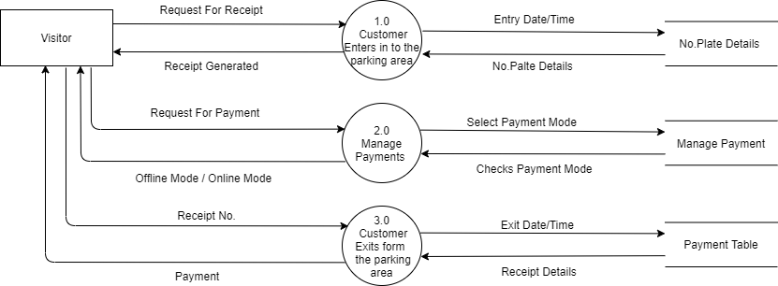

Fig.5.2.1: DFD Level 1: Visitor Side

**5.2.1** **DFD Level 2: Visitor Side:**

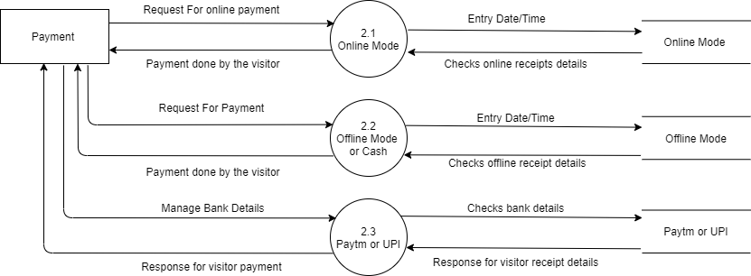

Fig.5.2.1: DFD Level 2: Visitor Side

**5.3.** **DFD Level 1: Admin Side:**

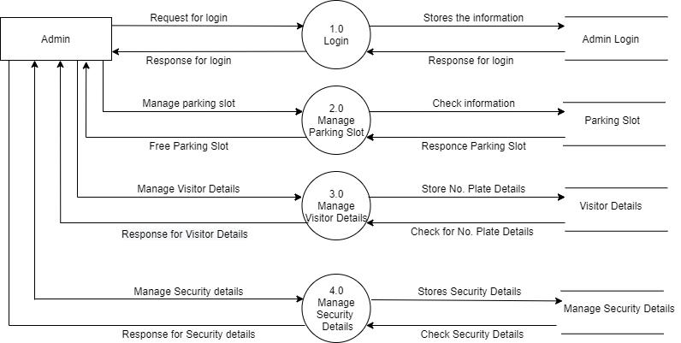

Fig.5.3.1: DFD Level 1: Admin Side

**5.4.** **DFD Level 1 – Security Guard:**

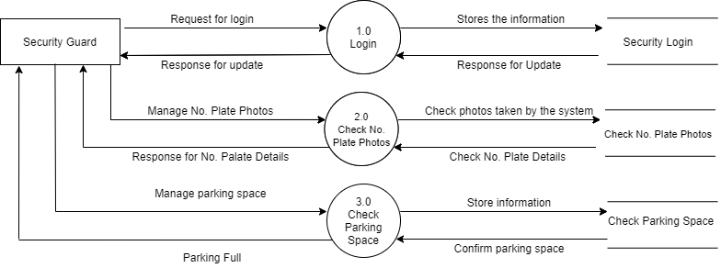

Fig.5.4.1: DFD Level 1: Security Guard

**Chapter 6**

**6. Use Case Diagram**

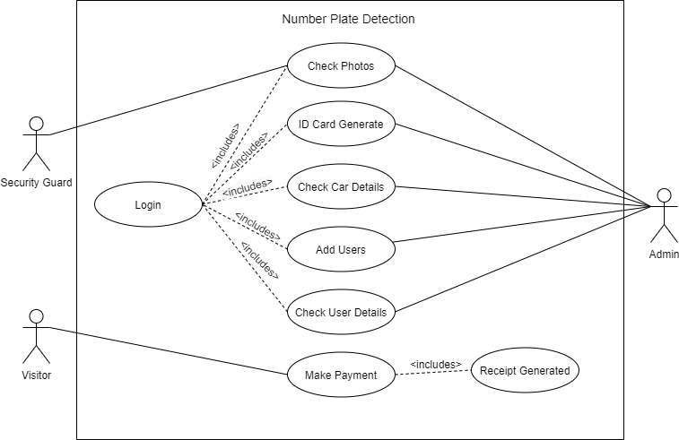

Fig.6.1.1: Use Case Diagram

**Chapter 7**

**7. Class Diagram**

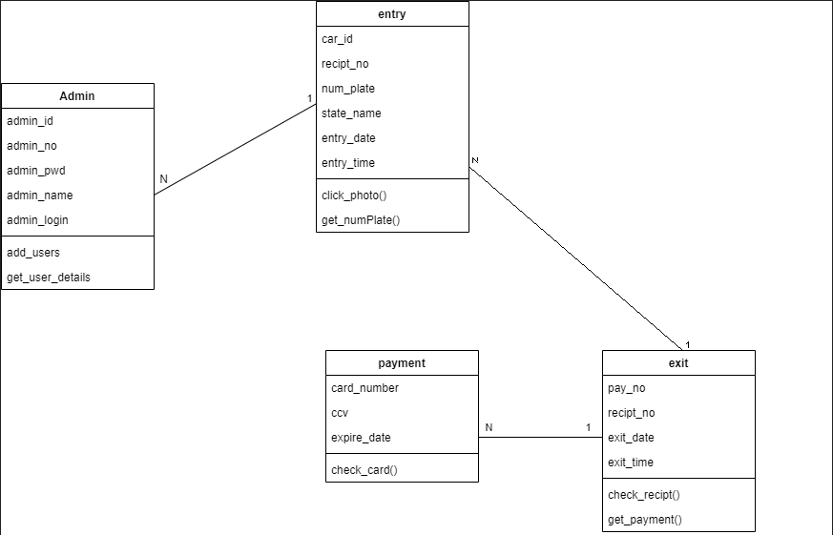

Fig.7.1.1:Class Diagram

**Chapter 8**

**8. Activity Diagram**

**8.1 Description of Activity Diagram**

**8.1.1 Definition of Activity Diagram:**

**Activity Diagram** is another important behavioural diagram in UML to describe dynamic aspects of the system. **Activity Diagram** is essentially an advanced version of **Flow Chart** that modelling the flow from one activity to another activity.

We use Activity Diagrams to illustrate the flow of control in a system and refer to the steps involved in the execution of a use case. We model sequential and concurrent activities using activity diagrams. So, we basically depict workflows visually using an activity diagram. An activity diagram focuses on condition of flow and the sequence in which it happens. We describe or depict what causes a particular event using an activity diagram.

UML models basically three types of diagrams, namely, structure diagrams, interaction diagrams, and behavior diagrams. An activity diagram is a behavioral diagram i.e., it depicts the behavior of a system.

An activity diagram portrays the control flow from a start point to a finish point showing the various decision paths that exist while the activity is being executed. We can depict both sequential processing and concurrent processing of activities using an activity diagram. They are used in business and process modelling where their primary use is to depict the dynamic aspects of a system.

An activity diagram is very similar to a flowchart.

**8.1. User side Activity Diagram:**

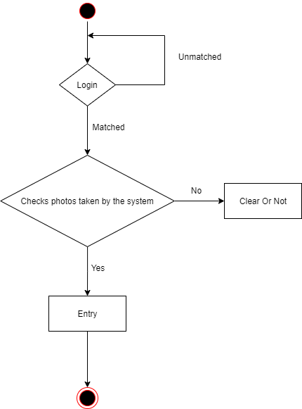

Fig.8.1.1:User side activity Diagram

**8.2.1 Visitor side Activity Diagram:**

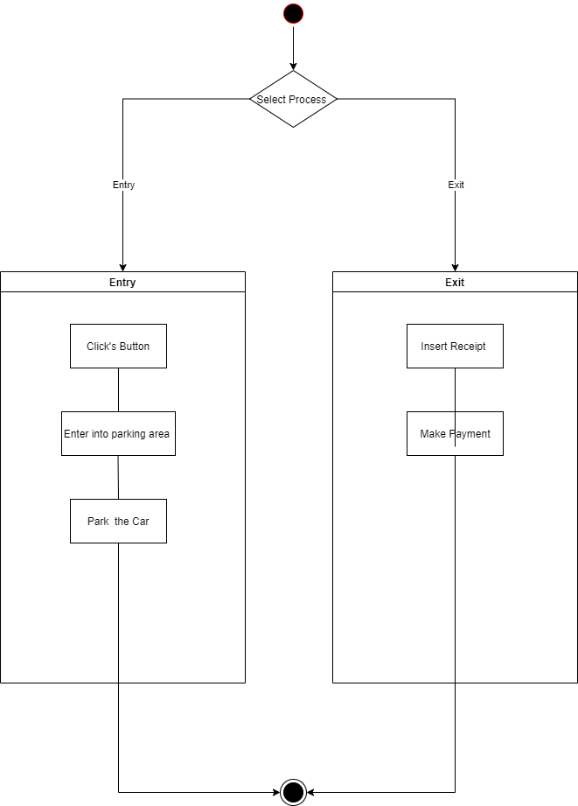

Fig.8.2.1:Visitor side Activity Diagram

**Chapter 9**

**9. E-R Diagram**

**9.1 E-R Diagram Description:**

An entity relationship diagram (ERD) shows the relationships of entity sets stored in a database. An entity in this context is an object, a component of data. An entity set is a collection of similar entities. These entities can have attributes that define its properties.

By defining the entities, their attributes, and showing the relationships between them, an ER diagram illustrates the logical structure of databases. ER diagrams are used to sketch out of the design database.

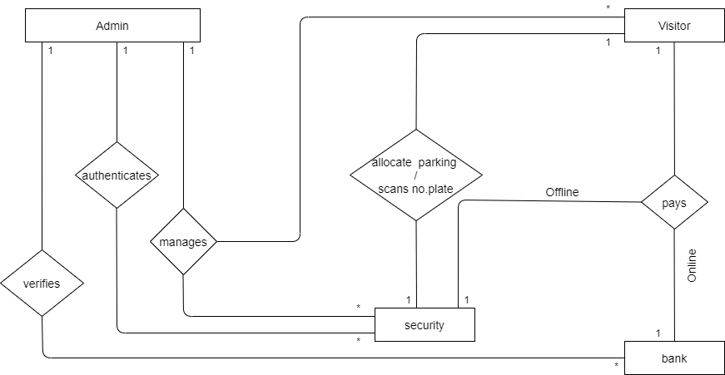

Fig.9.1.1: E-R diagram

**Chapter 10**

**10. Data Dictionary**

**10.1. Description of data dictionary:**

A Data Dictionary is a collection of names, definitions, and attributes about data elements that are being used or captured in a database, information system, or part of a research project. It describes the meanings and purposes of data elements within the context of a project, and provides guidance on interpretation, accepted meanings, and representation. A Data Dictionary also provides metadata about data elements. The metadata included in a Data Dictionary can assist in defining the scope and characteristics of data elements, as well the rules for their usage and application.

**Admin_Table:**

|  |  |  |  |  |  |
| --- | --- | --- | --- | --- | --- |
| **Sr. No** | **Field Name** | **Size** | **Description** | **Constraint** | **Example** |
| 1 | Admin_user | Varchar (5) | ID of Admin | P. K | ad100, ad101 |
| 2 | Admin_Name | Varchar (45) | Name of the Admin | Not Null | Jeet, Nipun, Tariro |
| 3 | Admin_E-mail | Varchar (50) | E-mail of the Admin | Not Null | Jeet123@gmail.com |
| 4 | Admin_Phone | Number (10) | Phone no. of Admin | Not Null | 9150321231 |
| 5 | Admin_DOB | Date | DOB of Admin  Before 18 years | Not Null | 12/6/1995 |
| 6 | Admin_Pass | Varchar (32) | Password for Login | Not Null | **************** |

Table 10.1.1

**Security_Table:**

|  |  |  |  |  |  |
| --- | --- | --- | --- | --- | --- |
| **Sr. No** | **Field Name** | **Size** | **Description** | **Constraint** | **Example** |
| 1 | Security_Id | Varchar (5) | ID of User | P.K | u100, u101 |
| 2 | Security_Name | Varchar (25) | Name of the User | Not Null | Jeet, Nipun, Tariro |
| 3 | Phone_No | Varchar (10) | Number of the user | Not Null | 9150321231 |
| 4 | Email_Id | Varchar (50) | Email Id of the user | Not Null | Jeet123@gmail.com |
| 5 | Security_Pass | Number (20) | Password for Login | Not Null | 12/6/1995 |
| 6 | Security_DOB | Date | DOB Of User Before 18 years | Not Null | ******************* |

Table 10.1.2

**Vistor_Table:**

|  |  |  |  |  |  |
| --- | --- | --- | --- | --- | --- |
| **Sr. No** | **Field Name** | **Size** | **Description** | **Constraint** | **Example** |
| 1 | Parking_date | Date | Parking date of the cars | P.K, A.I | 12/9/2021 |
| 2 | Receipt_no | Varchar (5) | Receipt no of the car | Not Null | Rt101, |
| 3 | Parking_slot | Varchar (6) | Parking slot allocated by the system | Not Null | Slot 5 |
| 4 | Car_number | Varchar (100) | Allots the no.  Of car by system | Not Null | 25 |
| 4 | Parking_Entry time | Date | Exit date of the car | Not Null | 12/9/2021 |
| 5 | Parking Exit_time | Time | Exit time of the car | Not Null | 12:01p.m. |

Table 10.1.3

**Car_Table:**

|  |  |  |  |  |  |
| --- | --- | --- | --- | --- | --- |
| **Sr. No** | **Field Name** | **Size** | **Description** | **Constraint** | **Example** |
| 1 | Sr_no | Varchar (5) | Sr.no of the car | U. K | 1, 2, 3, …. |
| 2 | Receipt_no | Varchar (5) | Receipt no of the car | P. K | Rt101, |
| 3 | Num_Plate | Varchar (15) | No. plate of the car | Not Null | GJ062135 |
| 4 | State_Name | Varchar (45) | State of the no. plate | Not Null | Gujarat, Mumbai, etc. |
| 5 | En_Date | Date | Date of entry | Not Null | 17/6/2021 |
| 6 | En_Time | Time | Time of entry | Not Null | 20:21p.m. |

Table 10.1.4

**Payment_Table:**

|  |  |  |  |  |  |
| --- | --- | --- | --- | --- | --- |
| **Sr. No** | **Field Name** | **Size** | **Description** | **Constraint** | **Example** |
| 1 | Receipt_no | Varchar (5) | Receipt no of the car | F. K | Rt101 |
| 2 | Pay mode | Varchar (6) | Mode of payment | Not Null | Cash / Paytm |
| 3 | Pay_Amt | Number (3) | Amount to pay | Not Null | 20rs,40rs,100rs |
| 4 | Exit_date | date | Exit date of the | Not Null | 12/9/2021 |
| 5 | Exit_time | time | Exit time of the | Not Null | 12:01p.m. |

Table 10.1.5

**Chapter 11**

**11. Development Phase Using Tkinter**

**Phase 1: Admin Dashboard:**

This shows the admin’s view when they login into the system.

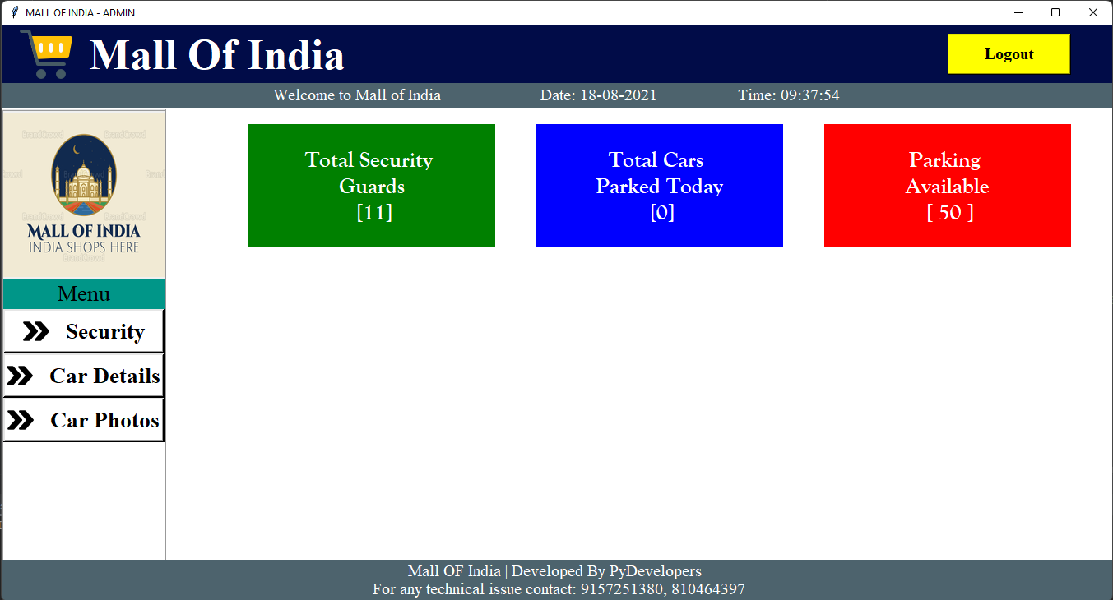

Fig 11.1: Admin Dashboard

**Phase 1: Admin Login:**

This shows the admin’s view when they open the system’s portal.

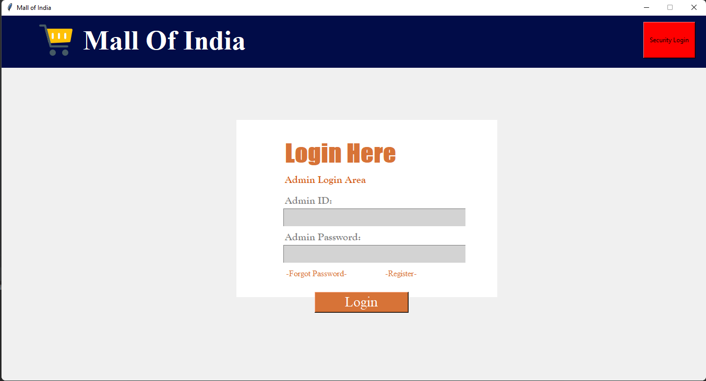

Fig 11.2: Admin Login

**Phase 2: Email generated for admin for forgot password with OTP:**

This shows the email otp if the admin is trying to recover their forgotten password.

Fig 11.3: Email generated for admin for forgot password with OTP

**Phase 3: Security Login:**

This shows the security guard’s view when they open the system’s portal to login.

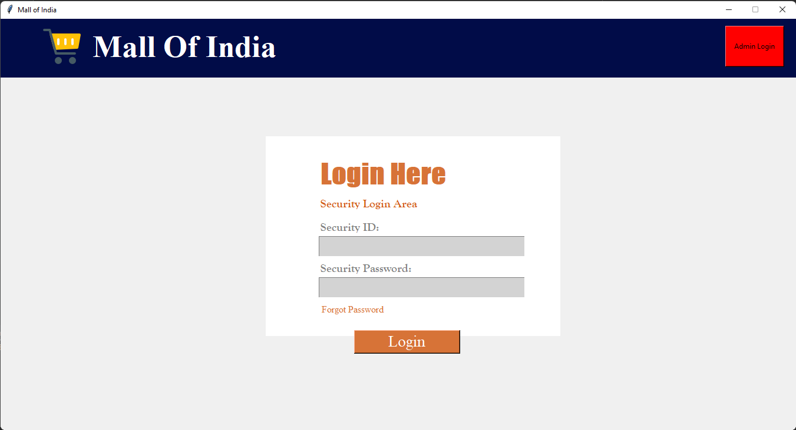

Fig 11.3.1: Security Login

**Phase 3:** **Security Id card generation:**

This shows when the admin is adding a new security to the database.

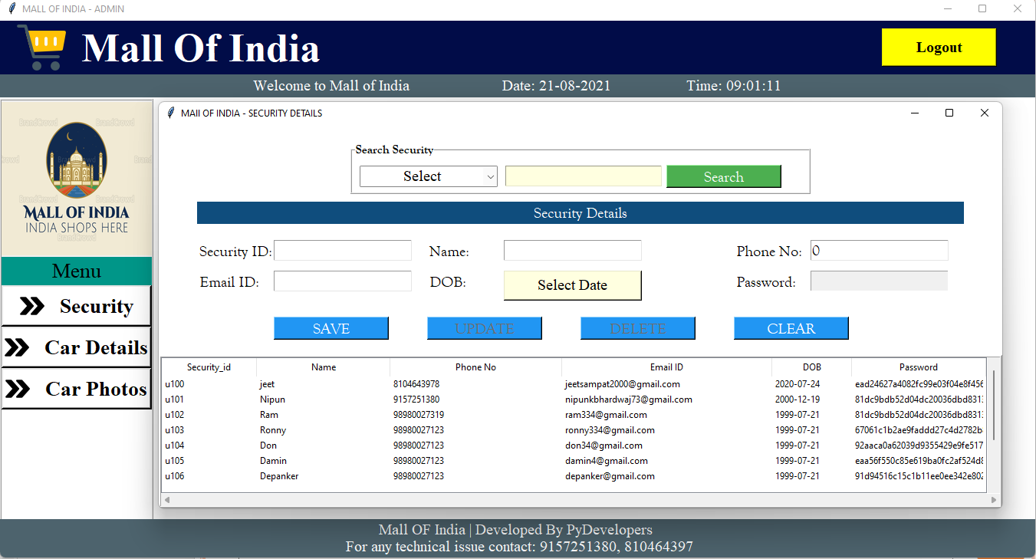

Fig 11.3.2: Security Id card generation

**Phase 3. Car details generation:**

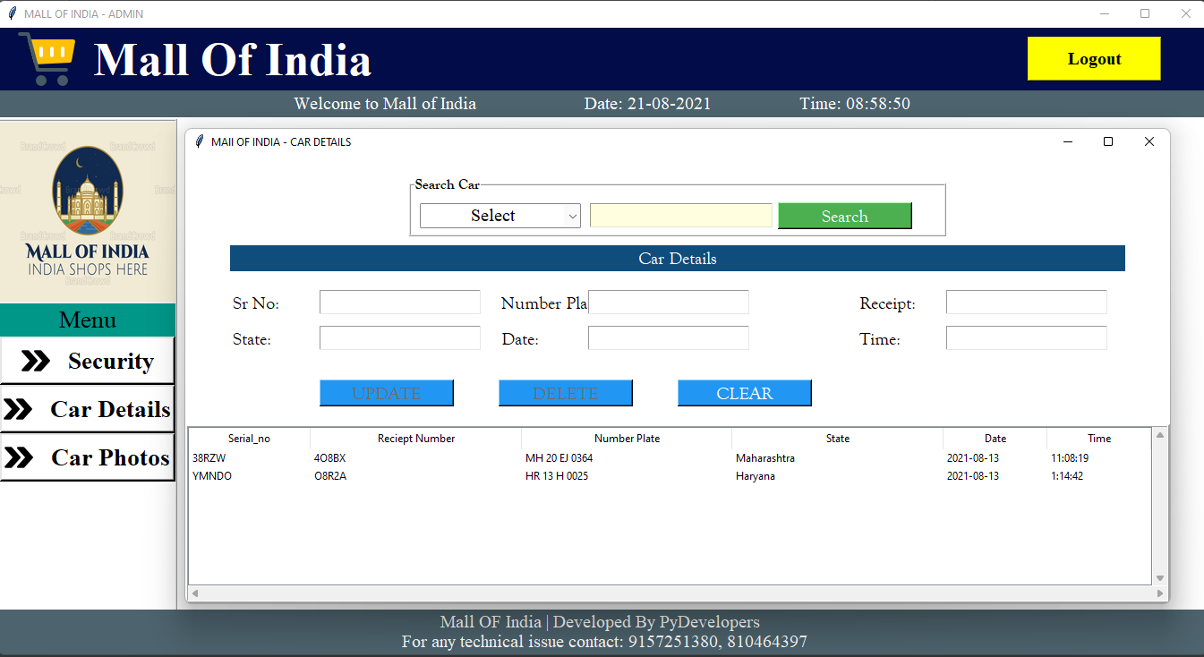

Fig 11.3.3 Car details generation

**Phase 4: Entry Mode:**

This shows when the system starts and interface is prompted by the security.

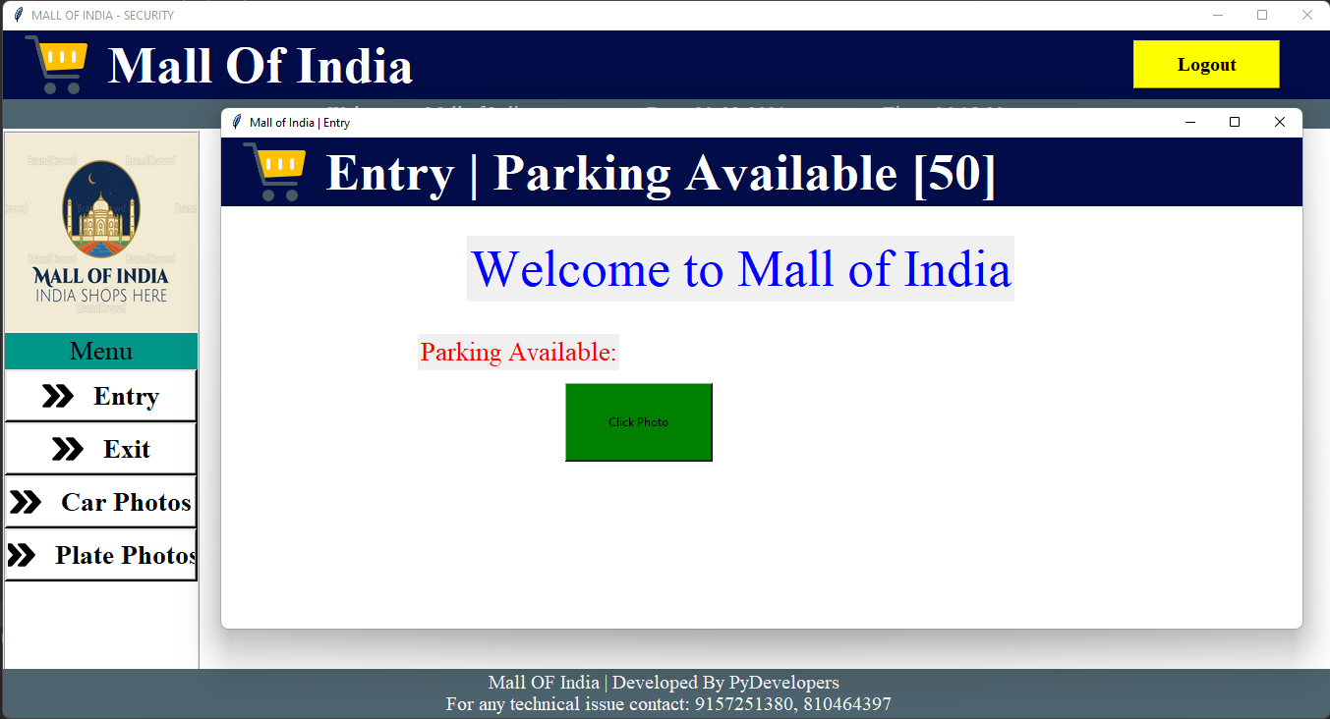

Fig 11.4: Entry Mode

**Phase 4: Exit Mode:**

This shows when the car is about to exit and security guard enters the details.

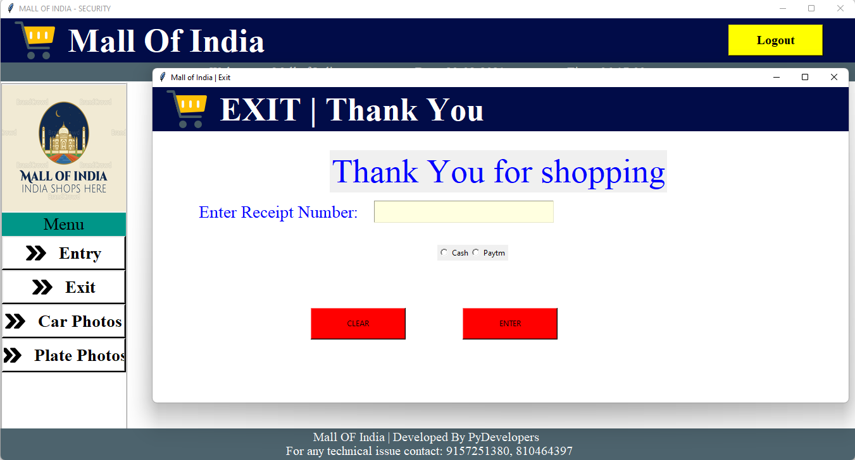

Fig 11.4.1: Exit Mode

**Chapter 12**

**12. Testing**

**12.1 Introduction to Testing**

**12.1.1 What is Testing?**

* Testing is vital to the success of the system. System testing makes a logical assumption that if all parts of the system are corrected, the goal will be successfully achieved. Inadequate testing or non-testing leads to errors that may not appear until months later.
* The testing of this project ensures that the data received by the user is accurate. The project gives details of different books available in the book stall according to the customer wish. This is ensured in the testing.
  + 1. **Importance of Testing**
* Testing is important because if there are any bugs or errors in the software, it can be identified early and can be solved before delivery of the software product. Properly tested software product ensures reliability, security and high performance which further results in time saving, cost effectiveness and customer satisfaction.
  + 1. **Types of Testing**
* Unit Testing
* Load Testing
* System Testing
* Performance Testing
* Manual Testing
  1. **Unit Testing**
     + Unit testing is a method of testing that verifies the individual units of source code are working properly. The goal of unit testing is to isolate each part of the program and show that the individual parts are correct. The N Unit a testing tool for C# will be used for unit testing.
  2. **Load Testing**
     + Load testing is the process of creating demand on a system or device and measuring its response. It generally refers to the practice of modeling the expected usage of a software program by simulating multiple users accessing the program concurrently. As such, this testing is most relevant for multi-user systems; often one built using a client/server model, such as web servers.
  3. **System Testing**
* Once the entire system has been built then it has to be tested against the Software Requirement Specification and System Specification to check if it delivers the features required. System testing can involve a number of specialist types of tests to see if all the functional and non-functional requirements have been met.
  1. **Performance Testing**
* The system should meet the performance requirements as mentioned in the Vision document. The performance will be evaluated based on the response time of the GUI and the database commands. Using JMETER tool performance testing will be done.
  1. **Manual Testing**
* Manual Testing will be done to ensure the correctness of various parts of the code using test cases generated by the tester.

**Chapter 13**

**13. Future Enhancement**

* The full video of car entering with exiting the parking area will been stored.
* We can use this system in university and colleges in future also.
* We can also provide slot no. for understanding where vehicle is going to park.
* In future we may add online booking for parking with slot number and online payment from home.
* Payment gateway will be added in the future.
* We will add API for payment in future also.
* Attendance of the security will be added.
* More security will be added for login.
* Photo will be taken for security guard for ID card.

**Chapter 14**

**14. References and Bibliography**

* Database - Database Management System (DBMS): A Practical Approach,

5th Edition Book - **Rajiv Chopra**

* Python GUI Programming with Tkinter: Develop responsive and powerful

GUI applications with Tkinter - **Alan D. Moore**

* Think Python: How to Think Like a Computer Scientist - **Allen B. D**
* Modules Description - <https>[://opencv.org/](https://opencv.org/)
* Documentation Reference - Previous Semester Project
* Idea -<https://pyorc.readthedocs.io/en/latest/#:~:text=PyORC%20is%20a%20Python%20module,in%20the%20Python%20standard%20library.&text=The%20module%20is%20compatible%20with%20Python%203.6%20or%20newer%20relss>
* <https://medium.com/programming-fever/license-plate-recognition-using-opencv-python-7611f85cdd6c>
* IEEE Recommended Practice for Software Requirements Specifications - IEEE Std 830-1998
* IEEE Standard for Software Test Documentation IEEE Std 829-1998
* IEEE Guide for Software Quality Assurance Planning - IEEE Std 730.1-1995
* All Respected Faculties.